Step 1: Prepare your system for migration
Remember that when you migrate from an old disk to a new one, you take with you all the garbage that has accumulated over months or years in the system folders. That's why it's worth doing some cleaning first. Throw away junk, uninstall unnecessary applications, delete folders and files you no longer need. Finally, go to the This PC panel and right-click on the old disk - select Properties -> Disk Cleanup, and then select Clean up system files. Check the boxes for all files to be deleted, including old and unnecessary system updates - there is no point in taking them with you.
Step 2: Make sure the old and new disks have the same partition system (GPT or MBR)
There are many ways to transfer the system to another disk - but each comes down to the same thing: using dedicated software that will copy all data from disk A to disk B. A large part of the programs are paid, others are free only with limited functionality. Everyone has their own "humors", so this should be anticipated already at the stage of preparing the system for copying. The two most common errors involve disk type and partition tables. The first error occurs when the system disk is dynamic and not primary. Not every program is able to deal with this problem by asking you to first convert from dynamic to basic disk. You can do it, but in my opinion it's a waste of time - it's better to use a program that can handle this problem on its own. I chose EaseUS Todo Backup Free 10.6. The second error comes down to Windows using two disk partition tables: GPT (GUID Partition Table) and MBR (Master Boot Record). The differences between them are not the subject of this guide, so I will just briefly mention that the newer (and usually better) standard is GPT.
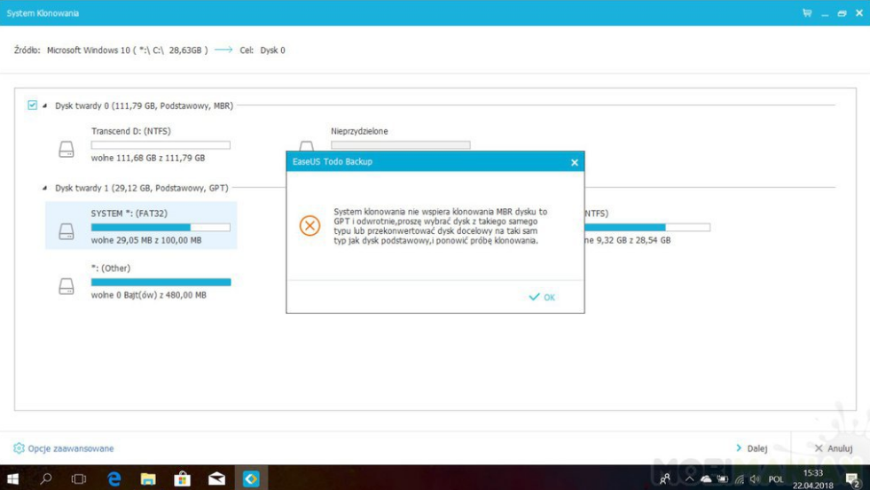

The problem is that your old drive may use one array and the newer one may use another. So, before cloning, you need to make sure that both media use the same table (whether it be MBR or GPT). It is best to perform the adaptation on a new, empty disk - changing the partition table without the appropriate software involves deleting data from the converted medium. Normally this would be a problem, but since cloning involves formatting the new drive anyway, you don't have to worry about it. The simplest, free and fastest recipe I know for changing the partition table is to use the built-in DiskPart tool in Windows 10. Here's how to do it, assuming your system uses a GPT partition table and you want to adapt your new disk to this standard: select Run from the Start menu and type diskpart and press Enter; enter the command "list disk" and press Enter - you will see a list of disks and their capacity; enter the command select disk x, where x is the number of the disk to be adapted (i.e. 0 in my case - this is the new disk to which I want to move the system); type the "clean" command and press Enter - warning, the data will be deleted! type the command convert gpt and press Enter. Ready. The new disk now uses the GPT partition table, so you can proceed to the next step. Below is a screenshot presenting all the system commands and responses.
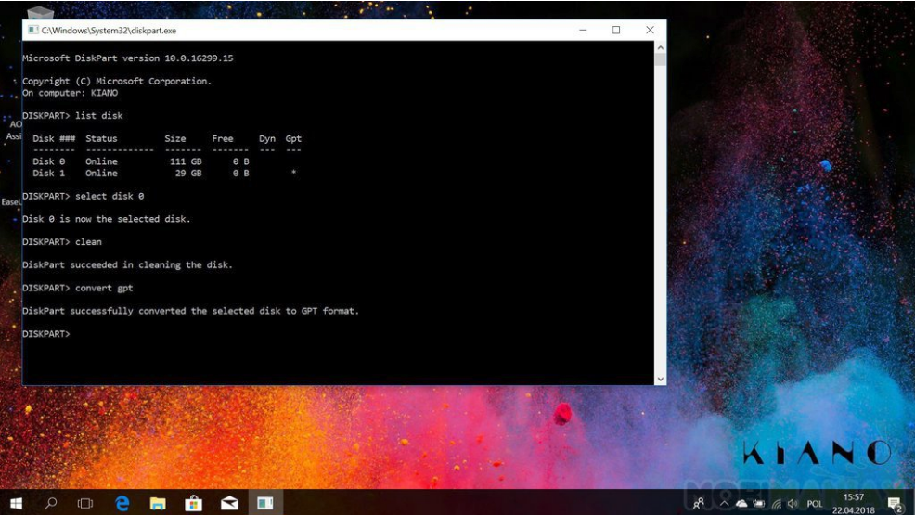

Step 3: Download EaseUS Todo Backup Free 10.6
I mentioned that I chose EaseUS Todo Backup Free 10.6 for the purposes of this guide. It is not my first choice because I prefer AOMEI Partition Assistant, however, the latter in the free version does not satisfactorily deal with dynamic disks. Hence, we stick with the EaseUS product. >>> Download EaseUS
>>> Pobierz program EaseUS Todo Backup Free 10.6
Todo Backup Free 10.6 EaseUS Todo Backup Free 10.6 has two significant advantages: it is free and easy to use.
Step 4: Clone the system
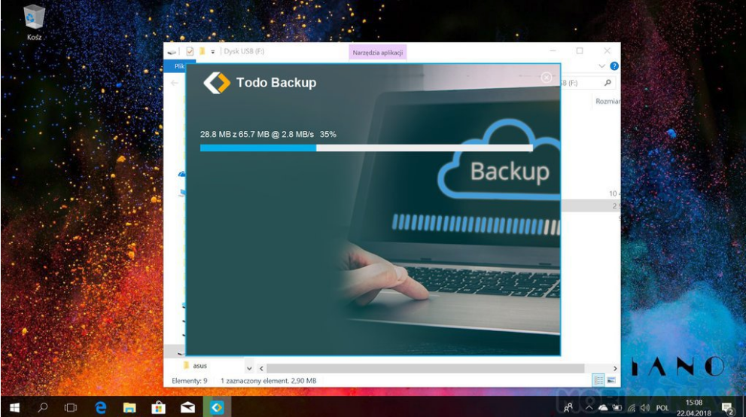
Install EaseUS Todo Backup Free 10.6 and launch it. At first, the application will ask for a license key, but you don't have to worry about it. For our needs, the free version is enough, so click Skip.
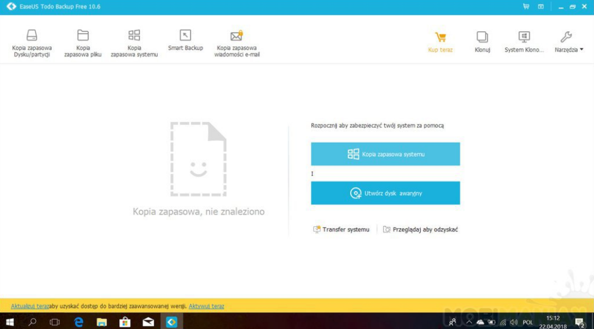
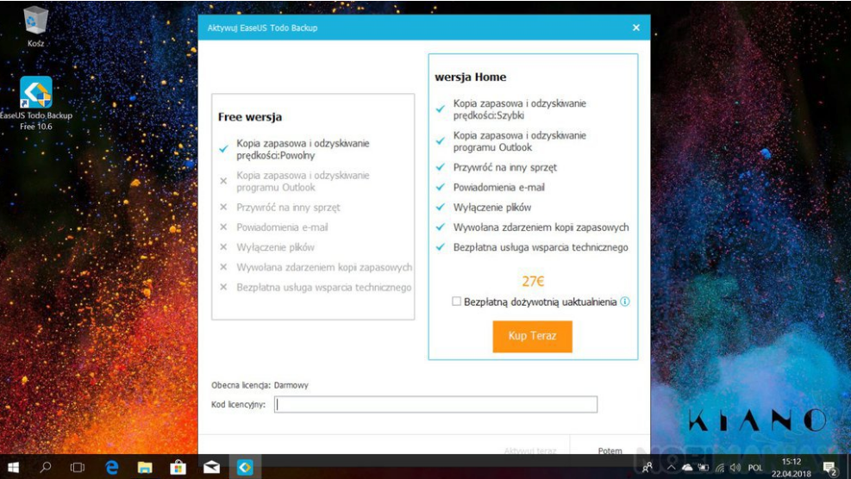

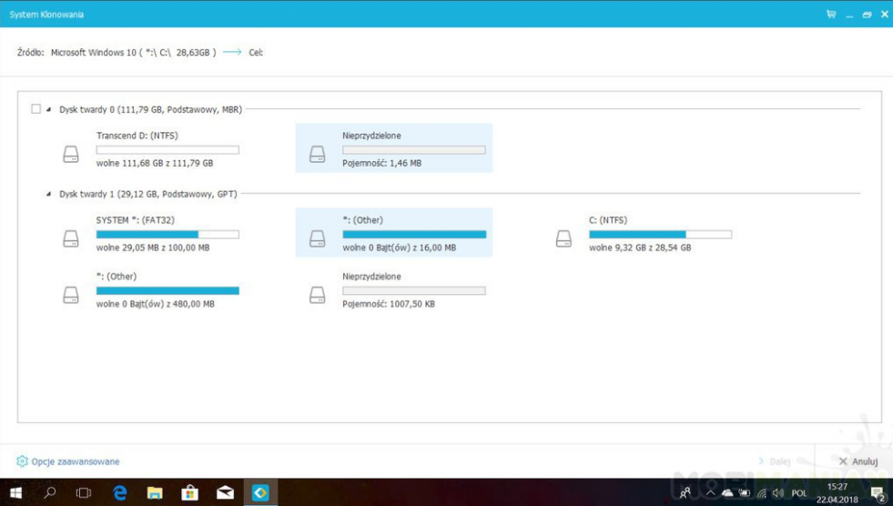
Now you can choose between two options. The simplest one is System Cloning. I recommend using it, because the program does almost everything for the user - your role is limited to indicating the disk to which you want to transfer the system and selecting the "Optimize for SSD" option from the advanced options menu. This solution has one drawback - it does not move the system recovery partition, so it will remain on the old disk. Decide for yourself whether this is a big problem for you. The second option is manual cloning, which you will find under the Clone button.
After pressing it, the system will ask you to select the source partitions (I recommend selecting the entire disk on which the system is located, instead of selecting individual partitions), and then select the target partition (i.e. the disk to which we want to copy the system - here I also recommend selecting default entire disk). Then, from the advanced options, we select Optimize for SSD and click next.
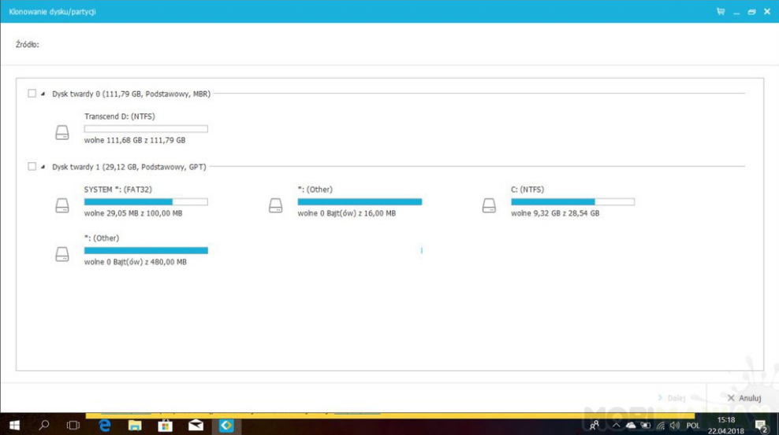

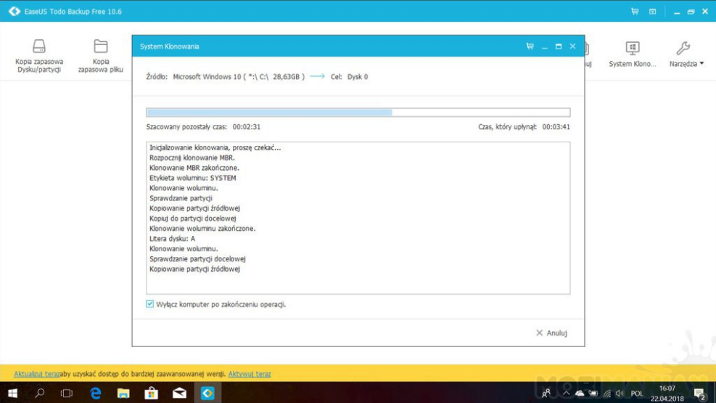

In both cases, you must wait a few or several minutes for the file copying to complete. After the operation is completed, an exact copy of the old media will appear on the new disk. Now it's time to make sure your computer knows which system to use.
Step 5: Set up the boot disk in the boot manager
If you have two identical systems, you need to determine which one will have priority at startup. To do this, you need to restart your computer and then enter the BIOS settings. Here is a short guide on how to perform this operation:
- turn on your computer (or restart it);
- next to the first board with the logo of the computer or motherboard manufacturer, press DEL, or F2, or F8 - or another button that is responsible for starting the BIOS on your computer (you will find the appropriate information in the manual, on the manufacturer's website, or on online forums) . In the case of the Kiano laptop example, this was the DEL key;
- enter the Boot Manager panel
- First, select the new disk to which you previously moved the system - you will recognize it by its name
- save settings and exit BIOS.
Step 6: Organize your drives
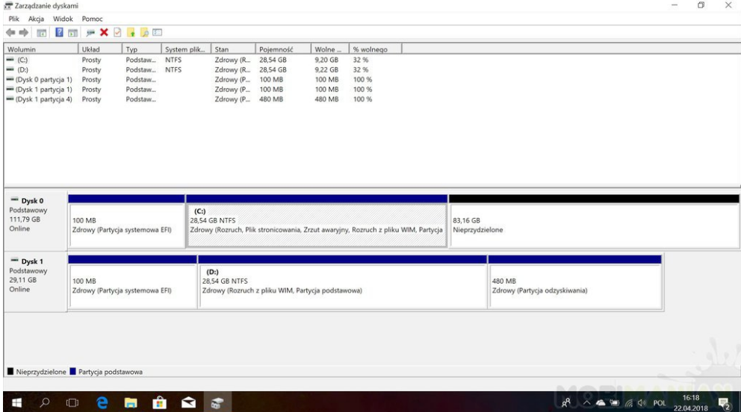
After starting the computer, you will probably notice immediately that the system has been loaded from a new medium - especially if you previously used an HDD and now the system files are stored on the SSD. The operation is almost over - there is only one thing left. If you go to the This PC panel, you will notice that the new disk has the same capacity as the old one. This is a problem: if the source disk was 32 GB (as in my example), this is how much space was reserved on the new medium, even if it offers, for example, 120 GB. Fortunately, this is easy to fix.
Right-click on the Start button, then select Disk Management. You will see a window in which all information about the disks installed in the system is collected. Look for a new medium. You will notice that apart from the space allocated to the cloned partition, the rest has a status of Unassigned.
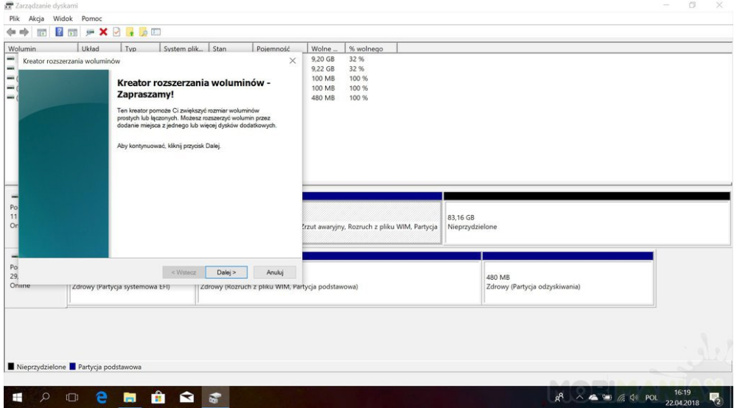

If you want the entire disk to be a system partition, right-click on the system allocated space and select Extend Volume. The wizard will guide you step by step through the entire process - it is best to leave everything in the default settings, which means that the system will allocate all free space to the system partition. If you prefer to play around with partitioning your disk into smaller sections, you can do so by right-clicking on the unallocated space and selecting the New Simple Volume option. A simple wizard will also appear here and will guide you through the entire process. Ready. If you did everything right, you now have your system on the new drive and it is set as your primary boot media. At this stage, you can unplug the old drive (if possible), but I recommend not cleaning or formatting it for some time. This may come in handy if you encounter unexpected problems after migrating to a new drive. Also remember that if you choose the simpler System Cloning method, you probably do not have a system recovery partition - so it is worth keeping the old media to have something to repair damaged Windows if necessary.

